Test Case: tc002_SPX_Dev5_Crear_Requisicion_Spot_Con_FAD_Tipo_Cobro_CC
Step 1 - Enter username and password and click to button Enter : Credentials Entered
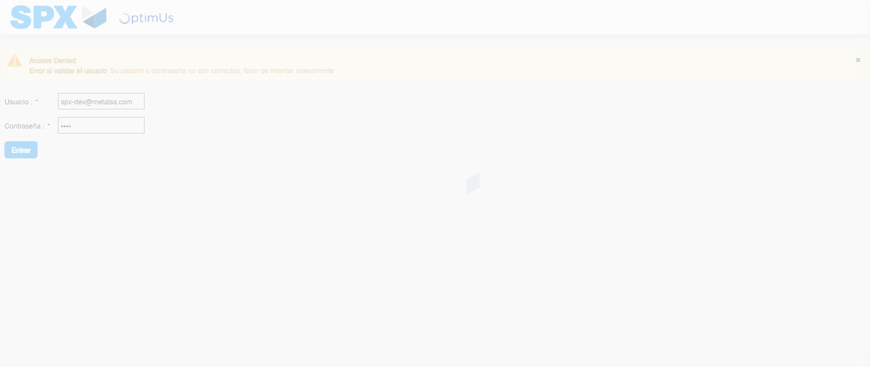Image file-name: QC_Testing-tc002_SPX_Dev5_Crear_Requisicion_Spot_Con_FAD_Tipo_Cobro_CC-1790175799790

Step 2 - Select to UEN and Access to Spot Buy Requisitions : UEN Correctly selected and Correct access
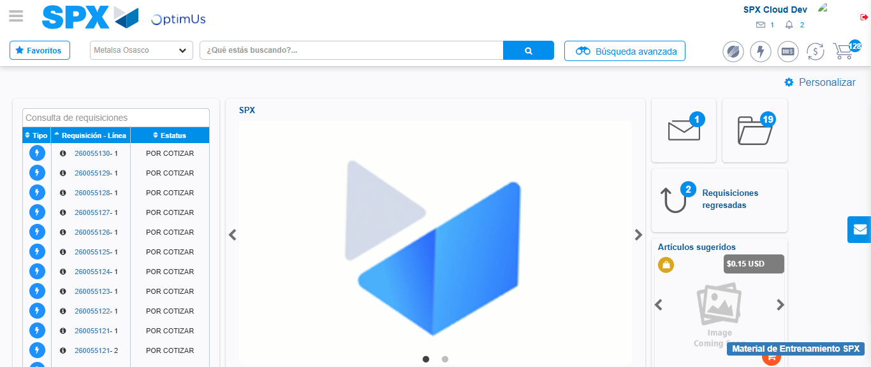Image file-name: QC_Testing-tc002_SPX_Dev5_Crear_Requisicion_Spot_Con_FAD_Tipo_Cobro_CC-1790175824167

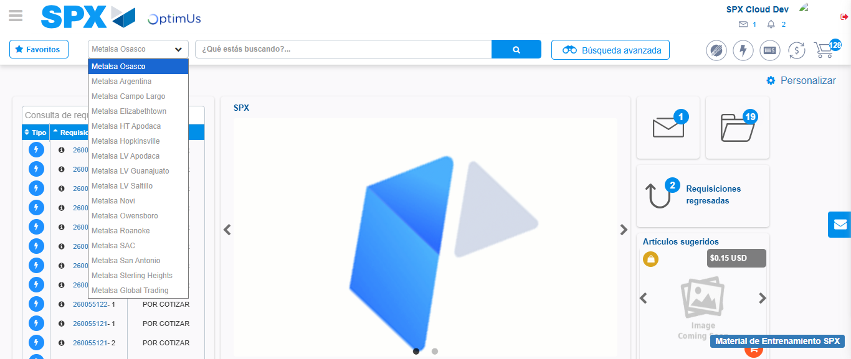Image file-name: QC_Testing-tc002_SPX_Dev5_Crear_Requisicion_Spot_Con_FAD_Tipo_Cobro_CC-1790175824823

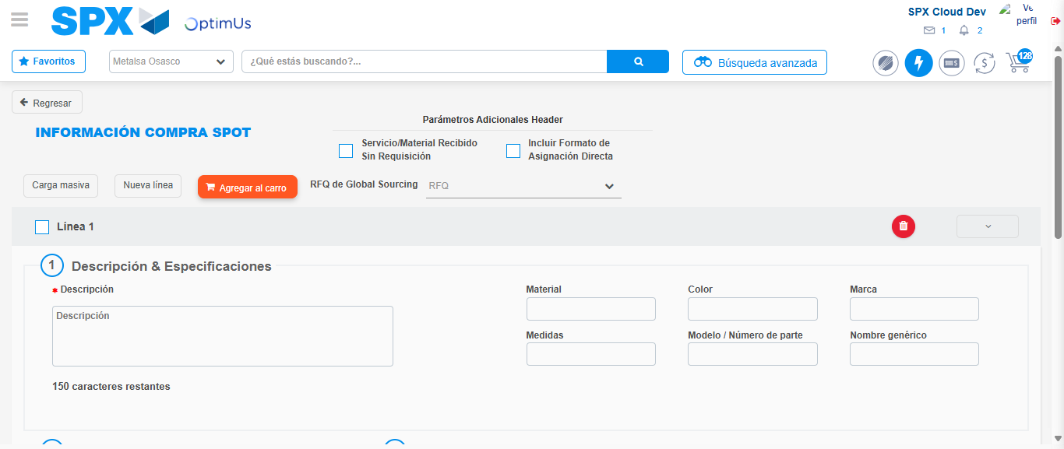Image file-name: QC_Testing-tc002_SPX_Dev5_Crear_Requisicion_Spot_Con_FAD_Tipo_Cobro_CC-1790175830592

Step 3 - Add FAD to Requisition: FAD Successfully Added
Image file-name: QC_Testing-tc002_SPX_Dev5_Crear_Requisicion_Spot_Con_FAD_Tipo_Cobro_CC-1790175830831

Image file-name: QC_Testing-tc002_SPX_Dev5_Crear_Requisicion_Spot_Con_FAD_Tipo_Cobro_CC-1790175831025

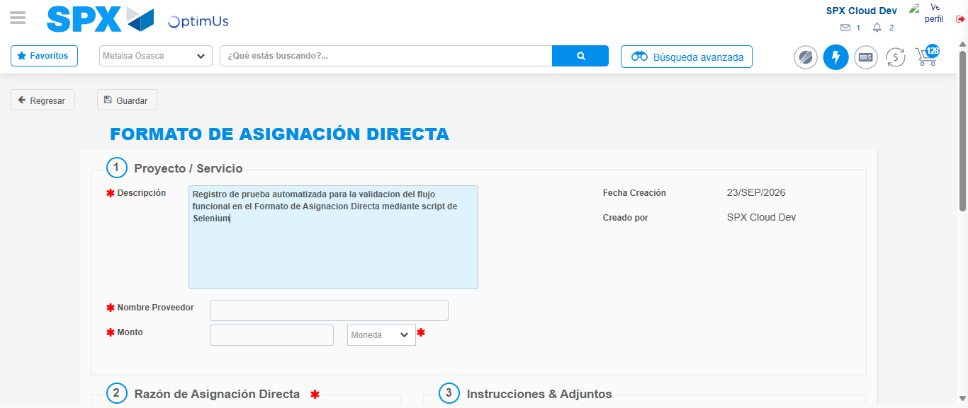Image file-name: QC_Testing-tc002_SPX_Dev5_Crear_Requisicion_Spot_Con_FAD_Tipo_Cobro_CC-1790175833952

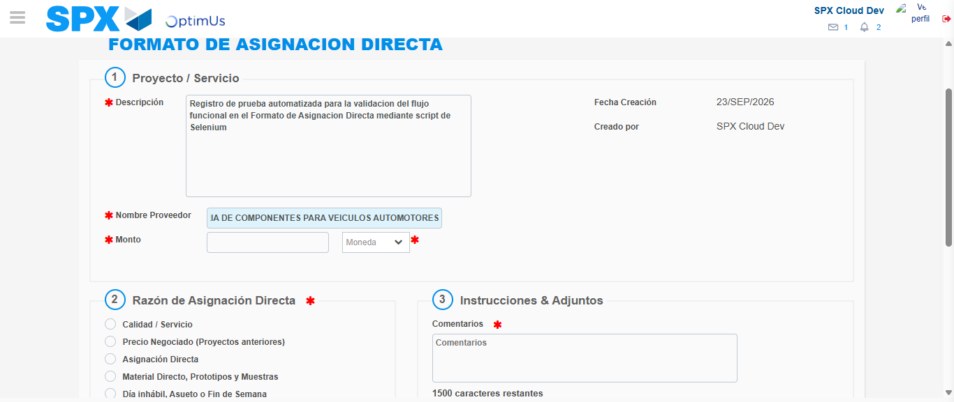Image file-name: QC_Testing-tc002_SPX_Dev5_Crear_Requisicion_Spot_Con_FAD_Tipo_Cobro_CC-1790175842806

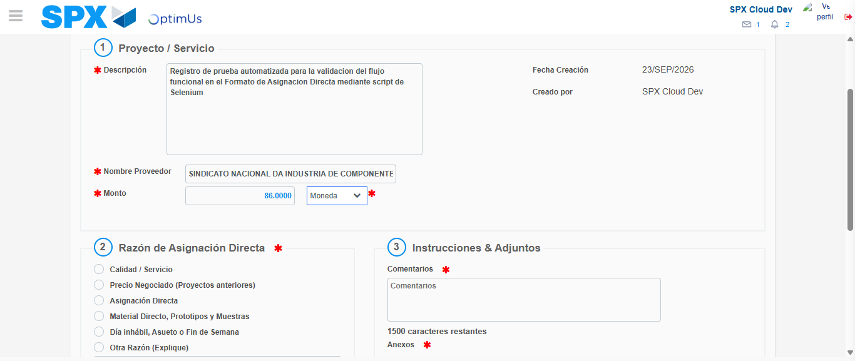Image file-name: QC_Testing-tc002_SPX_Dev5_Crear_Requisicion_Spot_Con_FAD_Tipo_Cobro_CC-1790175843141

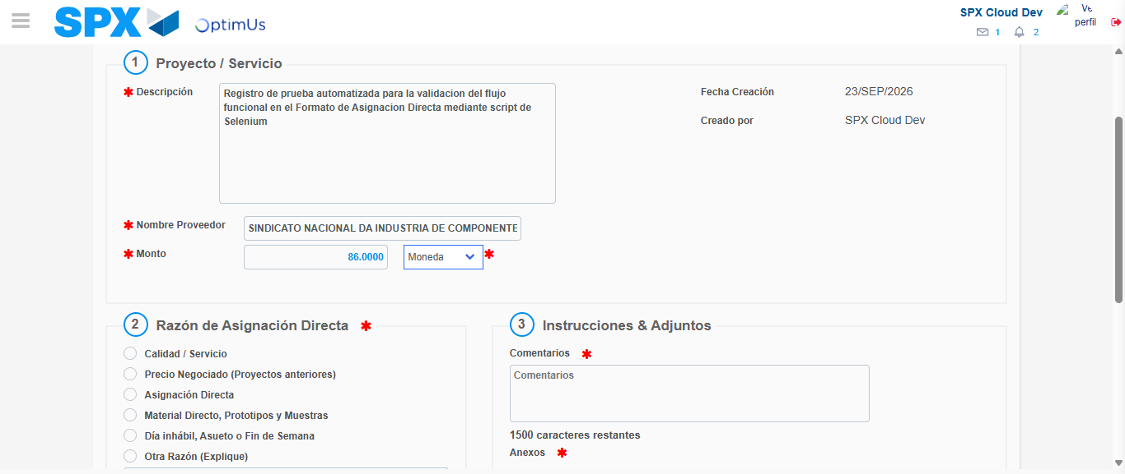Image file-name: QC_Testing-tc002_SPX_Dev5_Crear_Requisicion_Spot_Con_FAD_Tipo_Cobro_CC-1790175843316

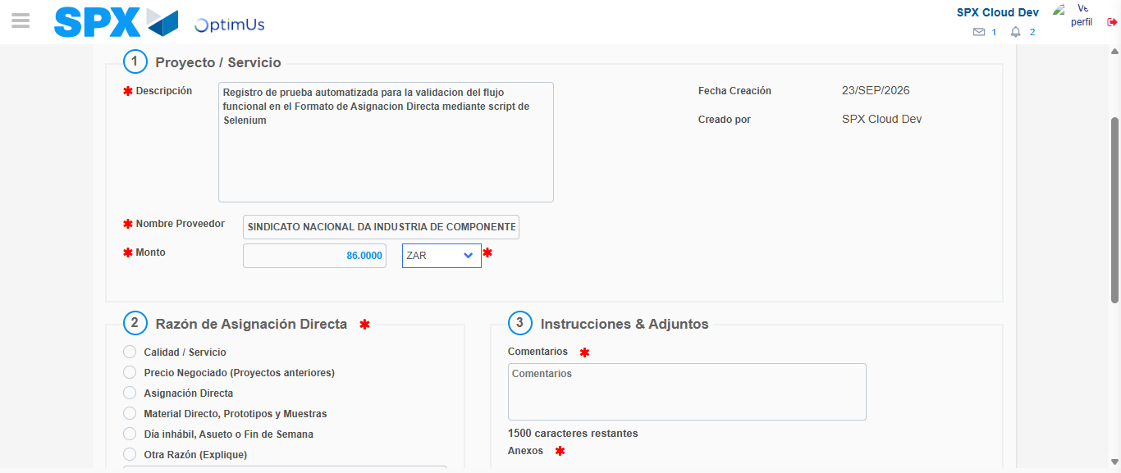Image file-name: QC_Testing-tc002_SPX_Dev5_Crear_Requisicion_Spot_Con_FAD_Tipo_Cobro_CC-1790175843590

Image file-name: QC_Testing-tc002_SPX_Dev5_Crear_Requisicion_Spot_Con_FAD_Tipo_Cobro_CC-1790175843783

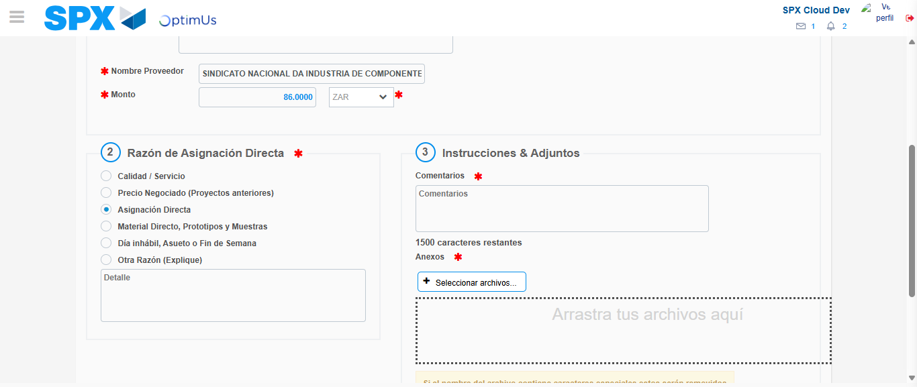Image file-name: QC_Testing-tc002_SPX_Dev5_Crear_Requisicion_Spot_Con_FAD_Tipo_Cobro_CC-1790175844566

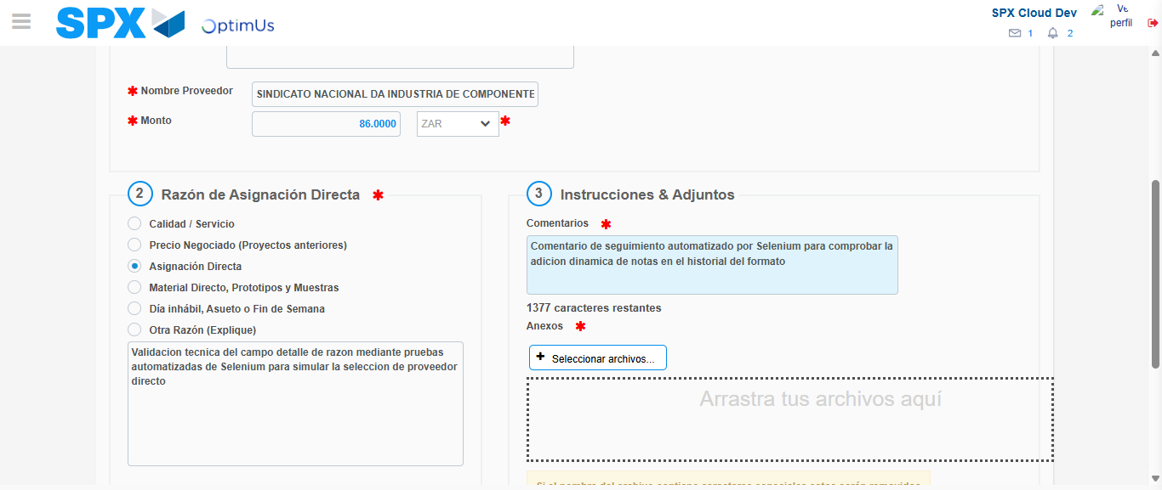Image file-name: QC_Testing-tc002_SPX_Dev5_Crear_Requisicion_Spot_Con_FAD_Tipo_Cobro_CC-1790175855471

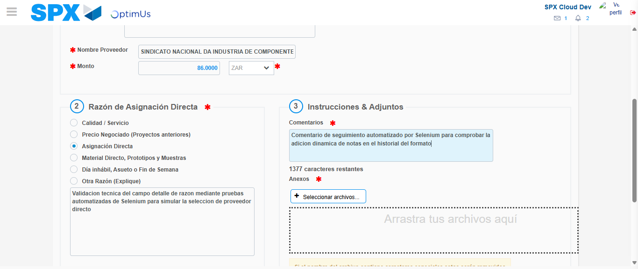Image file-name: QC_Testing-tc002_SPX_Dev5_Crear_Requisicion_Spot_Con_FAD_Tipo_Cobro_CC-1790175856011

Step 4 - Data Capture Spot Buy Requisition: Data captured correctly
Image file-name: QC_Testing-tc002_SPX_Dev5_Crear_Requisicion_Spot_Con_FAD_Tipo_Cobro_CC-1790175830831

Image file-name: QC_Testing-tc002_SPX_Dev5_Crear_Requisicion_Spot_Con_FAD_Tipo_Cobro_CC-1790175831025

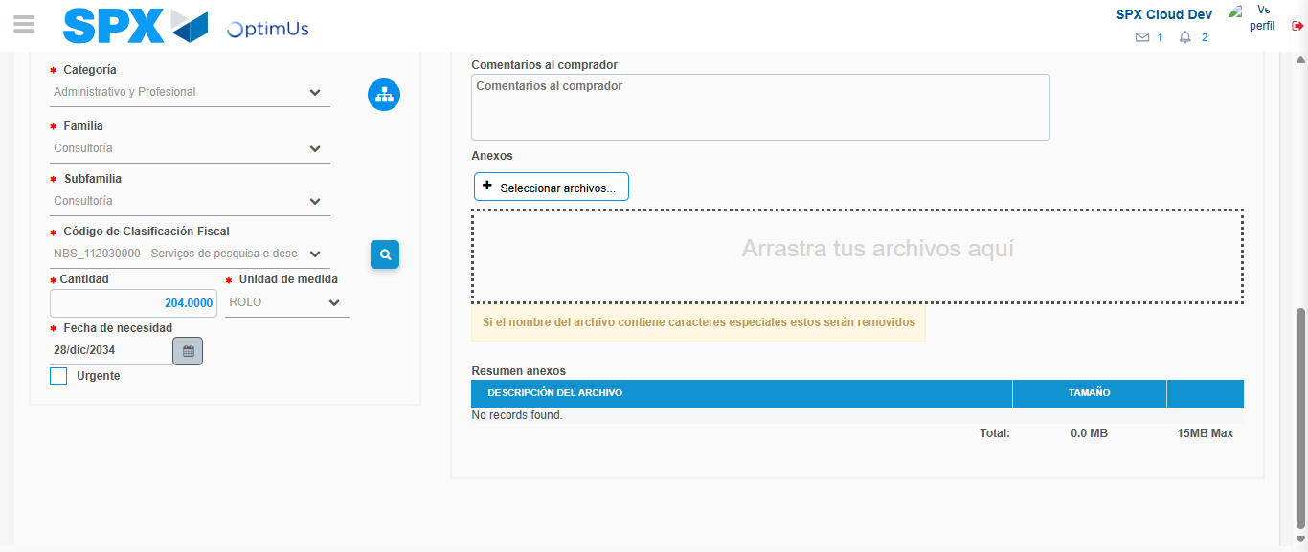Image file-name: QC_Testing-tc002_SPX_Dev5_Crear_Requisicion_Spot_Con_FAD_Tipo_Cobro_CC-1790175872694

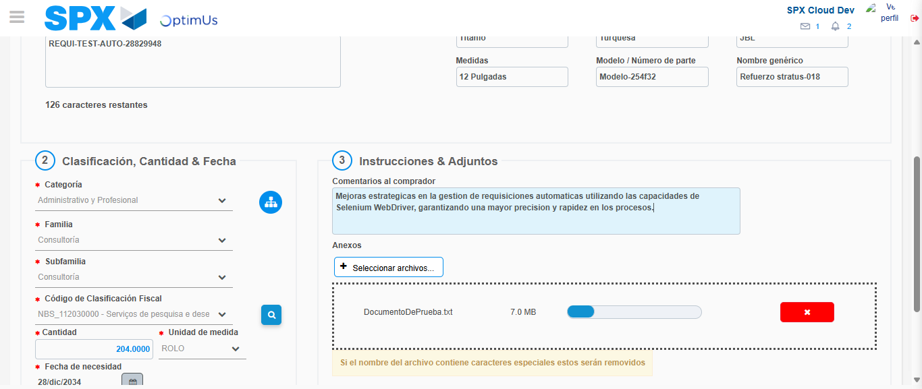Image file-name: QC_Testing-tc002_SPX_Dev5_Crear_Requisicion_Spot_Con_FAD_Tipo_Cobro_CC-1790175873616

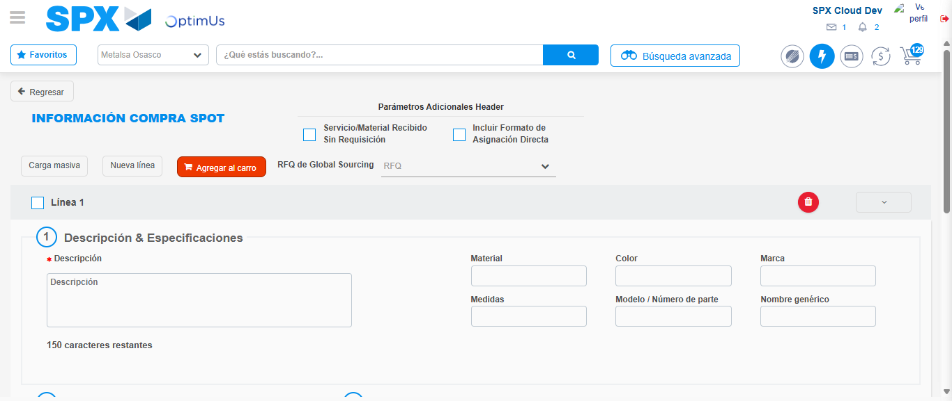Image file-name: QC_Testing-tc002_SPX_Dev5_Crear_Requisicion_Spot_Con_FAD_Tipo_Cobro_CC-1790175888646

Step 8 - Return to Main Page SPX : Return to Main Page SPX
Image file-name: QC_Testing-tc002_SPX_Dev5_Crear_Requisicion_Spot_Con_FAD_Tipo_Cobro_CC-1790175824167

Image file-name: QC_Testing-tc002_SPX_Dev5_Crear_Requisicion_Spot_Con_FAD_Tipo_Cobro_CC-1790175824823

Image file-name: QC_Testing-tc002_SPX_Dev5_Crear_Requisicion_Spot_Con_FAD_Tipo_Cobro_CC-1790175830592

Image file-name: QC_Testing-tc002_SPX_Dev5_Crear_Requisicion_Spot_Con_FAD_Tipo_Cobro_CC-1790175890846

Image file-name: QC_Testing-tc002_SPX_Dev5_Crear_Requisicion_Spot_Con_FAD_Tipo_Cobro_CC-1790175890996

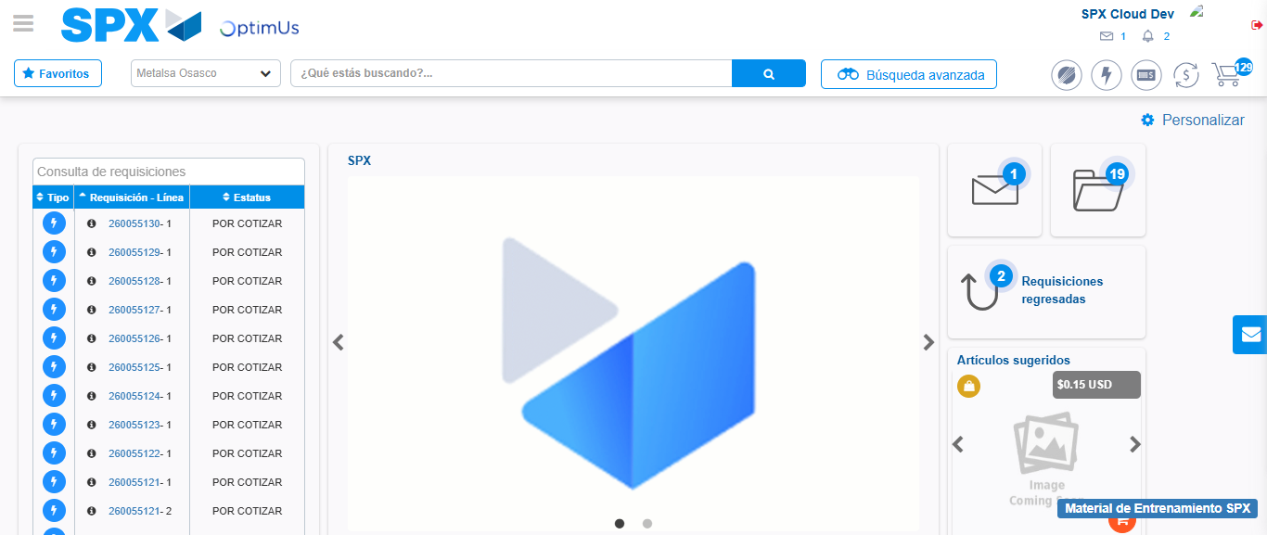Image file-name: QC_Testing-tc002_SPX_Dev5_Crear_Requisicion_Spot_Con_FAD_Tipo_Cobro_CC-1790175912046

Step 9 - Log Out : Log Out SPX
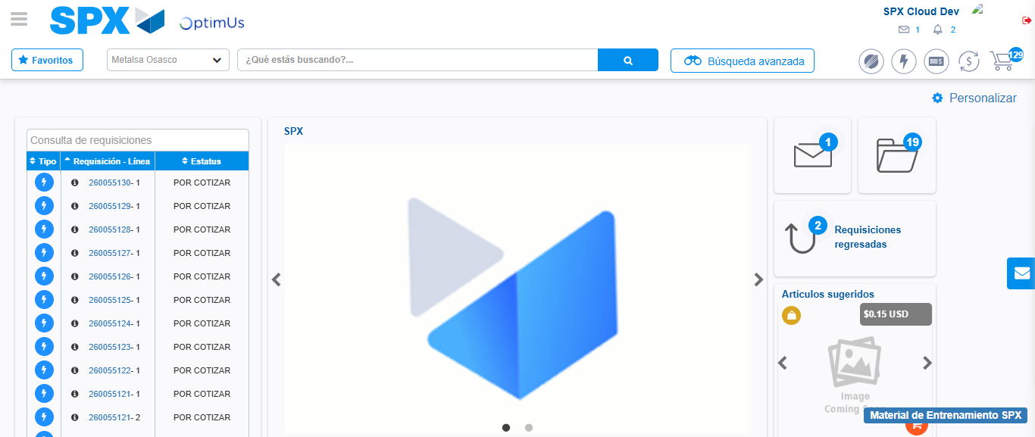Image file-name: QC_Testing-tc002_SPX_Dev5_Crear_Requisicion_Spot_Con_FAD_Tipo_Cobro_CC-1790175912310

